Python String format() ,Python string length | len() & Python String find() Method with Examples

## Python String format()

Python format() function is used to replace or convert the string with “{ }” with valid values in the output string. Format function help us in clean representation or you can say the human-readable representation of the string.

Let’s take a look at the syntax for using format() function.

|  |
| --- |
| Name = "Alex" String = "Hello my name is {}" String.format(Name) |

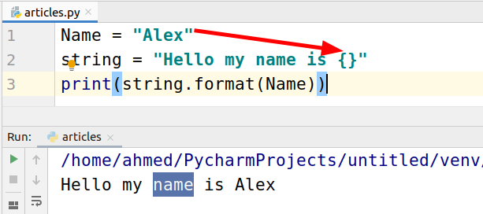

We can also replace the “{ }” with numbers. Let’s have a look at example.

|  |
| --- |
| Name = "Alex" for i in range(3):  string = "Hello my name is {}, {}"  print(string.format(Name, i)) |

The output is as following.

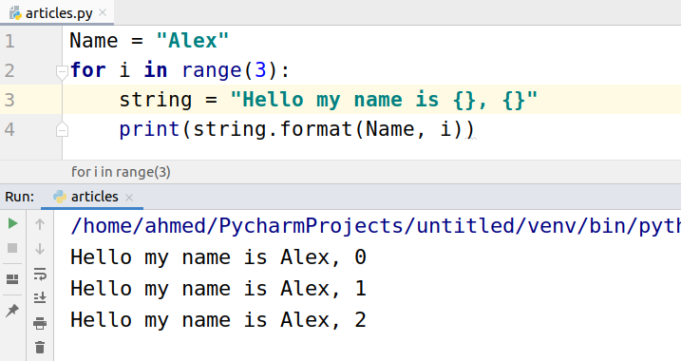

## Python string length function

Length function is used to find the length of the string. We can use the length function on a given string, array, list, tuple, and dictionary.

Let’s look at the syntax.

|  |
| --- |
| len(string) |

Let’s calculate the length of a string.

|  |
| --- |
| Name = "Alex" print(len(Name)) |

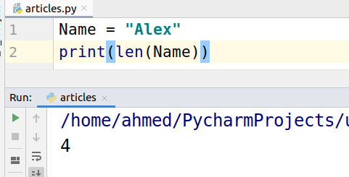

Let’s take a look at another example. In the example below spaces are also included in the calculation of the length of the string.

|  |
| --- |
| Name = "My name is Alex" print(len(Name)) |

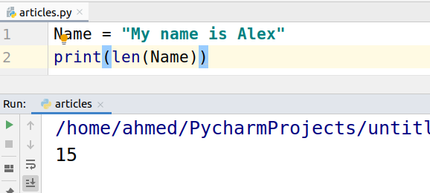

## Python String find()

The Python string find() function is used to find the index of the first occurrence of the substring in the given string.

Let’s find ‘e’ index in ‘Alex’ string.

|  |
| --- |
| Name = "Alex" print(Name.find('e')) |

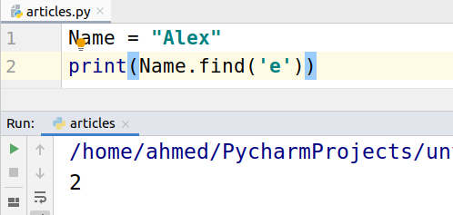

As the index starts from 0, ‘A’ comes at 0 indexes, ‘B’ comes at 1st index and ‘e’ comes at 2 indexes.

For searching in a string we can also pass the starting and ending position.

|  |
| --- |
| Name = "Alex is my name" print(Name.find('my',5,10)) print(Name.find('my',0,5)) |

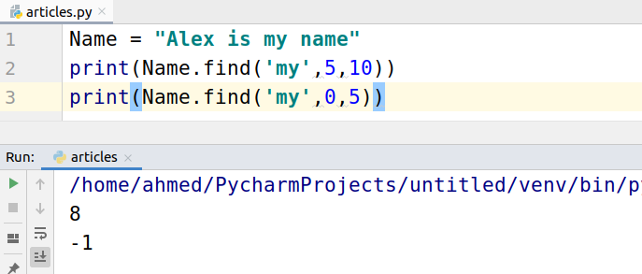

-1 stand for not found.